### AzureChat Bookscape

### (Deployment of secure infrastructure & AI services for public placing platform using Microsoft Azure)

**A MAJOR PROJECT REPORT**

***Submitted by***

**Vishwajeet Singh**

**2020-310-238**

***In partial fulfilment for the award of the degree of***

B. TECH COMPUTER SCIENCE AND ENGINEERING

***Under the supervision of***

Mr. Tabrej Ahmad khan



Department of Computer Science & Engineering School of Engineering Sciences & Technology

**JAMIA HAMDARD**

**New Delhi-110062**

## (2024)

## DECLARATION

I, Mr. Vishwajeet Singh a student of Bachelors in Technology Computer Science and Engineering (B.Tech CSE), (Enrolment No: 2020-310- 238) hereby declare that the Project/Dissertation entitled “AzureChat Bookscape” which is being submitted by me to the Department of Computer Science, Jamia Hamdard, New Delhi in partial fulfilment of the requirement for the award of the degree of Bachelors in Technology Computer Science and Engineering (B.Tech CSE) , is my original work and has not been submitted anywhere else for the award of any Degree, Diploma,

Associateship, Fellowship or other similar title or recognition.

Vishwajeet Singh

Date: (Signature and Name of the Applicant)

Place: Jamia Hamdard

### ACKNOWLEDGEMENT

I would want to express my gratitude to a number of persons who have encouraged and assisted me in the preparation of this project, both directly and indirectly. It allows me to look back and reflect on the support I've had during this process.

I would like to express my gratitude to Mr. Tabrej Ahmad Khan, my mentor, as well as the professors of Jamia Hamdard University, for their invaluable recommendations, innovative criticisms, and support throughout the writing process. I would like to offer my heartfelt gratitude to the entire faculty of Jamia Hamdard University (SEST).

My heartfelt gratitude goes out to my family and friends, as well as my esteemed university, Jamia Hamdard, for providing me with the chance and infrastructure to complete this project. Finally, I want to express my gratitude to everyone who assisted me in gathering data during the creation of the project, without whom it would not have been possible.

# AZURECHAT BOOKSCAPE

# (Deployment of secure infrastructure & AI services for public placing platform using Microsoft Azure)



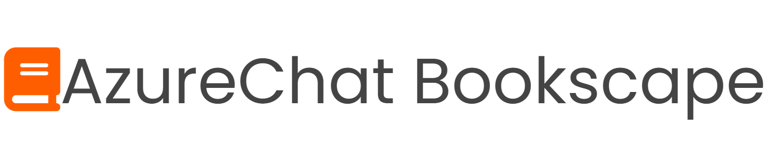

## Index

|  |  |  |
| --- | --- | --- |
| S.NO | TOPIC | PAGE NO |
| 1. | Objective | 7 |
| 2. | Introduction | 8 |
| 3. | Problem Statement | 9 |
| 4. | Need for AzureChat Bookscape | 10 |
| 5. | Methodology | 11-12 |
| 6. | Used components in AzureChat Bookscape | 13-18 |
| 7. | Azure Services used in Web app | 19-20 |
| 8. | Snapshots of project | 21-26 |
| 9 | Conclusion | 27 |
| 10. | Limitations | 28 |
| 11. | Future Scope | 29-31 |
| 12. | Bibliography | 32 |

**OBJECTIVE**

### The primary objectives of this report are to explain the concept, design, implementation, and use of the project titled “AzureChat Bookscape. This endeavor involves a thorough assessment of existing security risks and vulnerabilities inherent in deploying applications to the public domain. The report aims to outline a comprehensive Azure infrastructure blueprint that not only prioritizes security but also emphasizes scalability and accessibility for the intended application users and also tells about the Azure AI services like chatbot. To achieve this, industry-leading best practices and an array of Azure security services & Azure AI services will be strategically employed to shield against common threats including DDoS attacks, potential data breaches, and unauthorized access attempts. Robust identity and access management (IAM) policies will be developed and implemented to precisely govern user access to Azure resources and the application itself. Furthermore, the deployment plan will integrate a multi-layered security architecture, encompassing network security, encryption mechanisms, and vigilant monitoring tools to ensure the safeguarding of data both in transit and at rest. The selection and utilization of pertinent Azure services such as Azure App services, Azure AI services & Azure language studio will be instrumental in augmenting the protective measures of the infrastructure and use of AI services. Rigorous testing, inclusive of penetration testing and vulnerability assessments, will be conducted to identify and rectify any security gaps that may compromise the integrity of the Azure infrastructure. The formulation of robust incident response and recovery plans is imperative to swiftly mitigate the impact of potential security breaches or incidents that may affect the public-facing application hosted on Azure. Comprehensive documentation and guidelines for ongoing security maintenance, updates, and compliance adherence within the Azure environment will be provided. Continuous monitoring, evaluation, and the iterative enhancement of security measures will ensure the perpetuity of a robust and resilient secure infrastructure for the public-facing application.

## INTRODUCTION

In an era dominated by digital connectivity and online services, the secure deployment of public-facing applications and problem solving of customers stands as an essential cornerstone for businesses and organizations seeking to deliver seamless experiences while safeguarding sensitive data and user privacy.

In this context, the deployment of a Microsoft Azure secure infrastructure and Azure AI services assumes paramount importance, necessitating a meticulous approach that combines cutting-edge technology, robust architecture, and stringent security measures. This project embarks on a comprehensive exploration and implementation of strategies aimed at fortifying a public-facing application hosted on Microsoft Azure.

It delves into the intricate layers of security, scalability, and accessibility required to create a resilient infrastructure capable of withstanding the evolving threat landscape while ensuring uninterrupted service delivery to a broad user base. Through a strategic amalgamation of industry best practices, Azure's suite of security services, and a proactive stance toward mitigating potential risks, this project endeavors to outline a blueprint that not only prioritizes security but also addresses the intricate balance between user accessibility and system robustness and this project also highlights the AI services provided by Microsoft Azure.

By examining key elements such as identity and access management, network security, encryption mechanisms, and incident response strategies, this report aims to provide a comprehensive guide for designing, implementing, and maintaining a secure Azure infrastructure tailored explicitly for public-facing applications, thereby instilling trust, reliability, and resilience in the digital ecosystem.

# Problem Statement

The Problem is that now in today’s world security of a public placing platform

and addressing of customer’s problem is a serious issue and as many platforms

such as websites and apps does not have proper secure infrastructure and less

problem solving techniques for their customers.

Businesses and organizations facing problems like loss of crucial data,

hacking and DDoS attacks. Unable to answer queries of customer on

time and poor communication is also affecting the business.

For security issues platforms required secure infrastructure hosting and for

customer service problem solving on time and efficient communication

is required.

Therefore, the need of cloud infrastructure for securing hosting and AI

Services is required and hence both the issues can be solved by using

Microsoft Azure.

**Need For AzureChat Bookscape**

AzureChat Bookscape provides a solution for public placing platform for secure hosting and customer problem solving. An online bookstore interface, a common public placing platform is used for showing use of Microsoft Azure infrastructure and Azure AI services for secure hosting and Customer problem solving.

The data available on the web app is securely stored on Microsoft azure and then with the use of Azure App Services the application is hosted and is safe for use.

For customer service the web app has a chatbot to answer all the queries of the customer and provide affective answers. It is trained for solving customer queries and will provide guidelines to solve the issue immediately.

AzureChat Bookscape gives an ideal representation of secure hosting and efficient use of AI services. It has proper infrastructure to secure the site and also well efficient to handle customer queries. It uses the AKS and Azure language studio to solve the problem statement.

The Chatbot available for query answering is firstly trained and tested with the most common questions so that it is able to answer each and every query of the customer related to books.

# Methodology

The Methodology for developing AzureChat Bookscape cloud-based web app using VS code and Microsoft Azure involves several steps. Here is a detailed overview of the methodology

1. A web interface: Firstly, created a sample web page as a public placing platform for deployment using HTML, CSS & JavaScript. It is responsive web interface and can be used easily on PC And mobile devices.

1. Creating a chatbot: Created a chatbot for web interface using Azure AI services, by using Azure AI Studio we can create bot then we can train and test it for the public interactions and for answering all the queries regarding the web interface.
2. Deploying Web interface on Azure: Deploying the whole public placing platform on the Microsoft Azure. The Application Deployed on Azure contains all the essential files required for the display and work of the application.
3. Secure Hosting of the web interface: Using Azure Services for secure hosting of the application and it helps in avoiding DDoS attacks, Hacking, prevents data loss and insuring user’s safety.

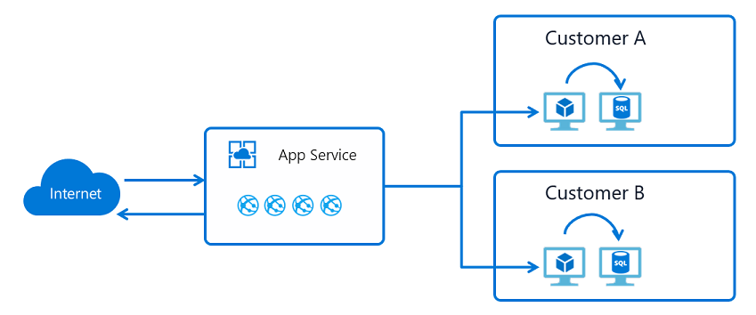

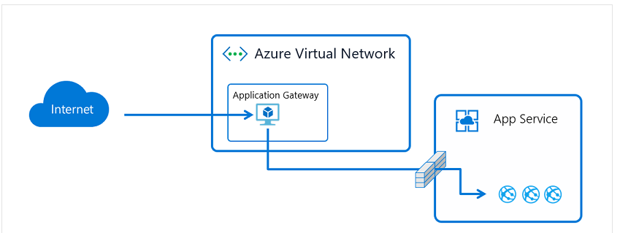

# Used components in AzureChat Bookscape

V S code: Visual Studio Code, commonly abbreviated as VS Code, is a popular source-code editor developed by Microsoft. It's known for its versatility, as it supports a wide range of programming languages like C++, C, python, Java etc. Offers various features such as debugging, syntax highlighting, code completion, and extensions (code runner, material theme, C/C++ intellisence etc.). Its lightweight yet powerful nature has made it a favorite among developers for tasks ranging from simple text editing to complex software development projects.

Key points and features about Visual Studio Code:

1. Cross-Platform Compatibility: Visual Studio Code is available for Windows, macOS, and Linux, ensuring that developers can use it regardless of their operating system they had in their PC.

2. Free and Open Source: VS Code is free to use and open source, which means it can be used by everyone and developers can contribute to its development and customize it according to their needs.

3. Intuitive Interface: It features a clean and intuitive user interface, with customizable layouts, themes, and keyboard shortcuts and it is easy to understand.

4. Extensions: One of the most powerful aspects of VS Code is its vast ecosystem of extensions. These extensions add functionality such as support for additional programming languages, debugging tools, version control systems, and many more.

5. Integrated Terminal: VS Code includes an integrated terminal, allowing developers to execute commands, run scripts, and interact with their development environment without leaving the editor and code can be executed smoothly.

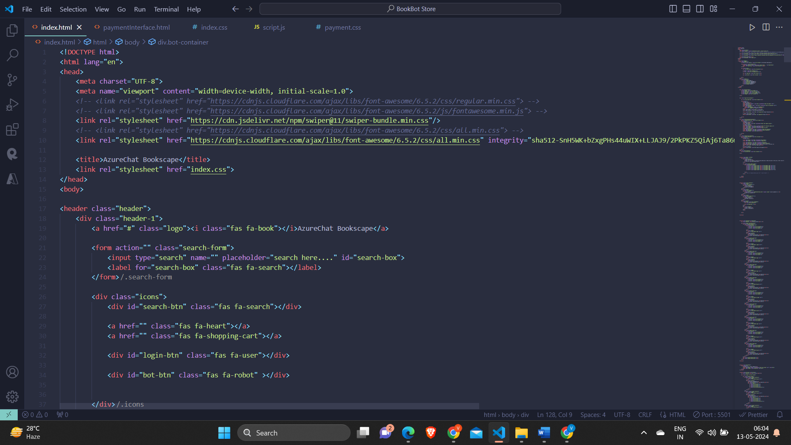

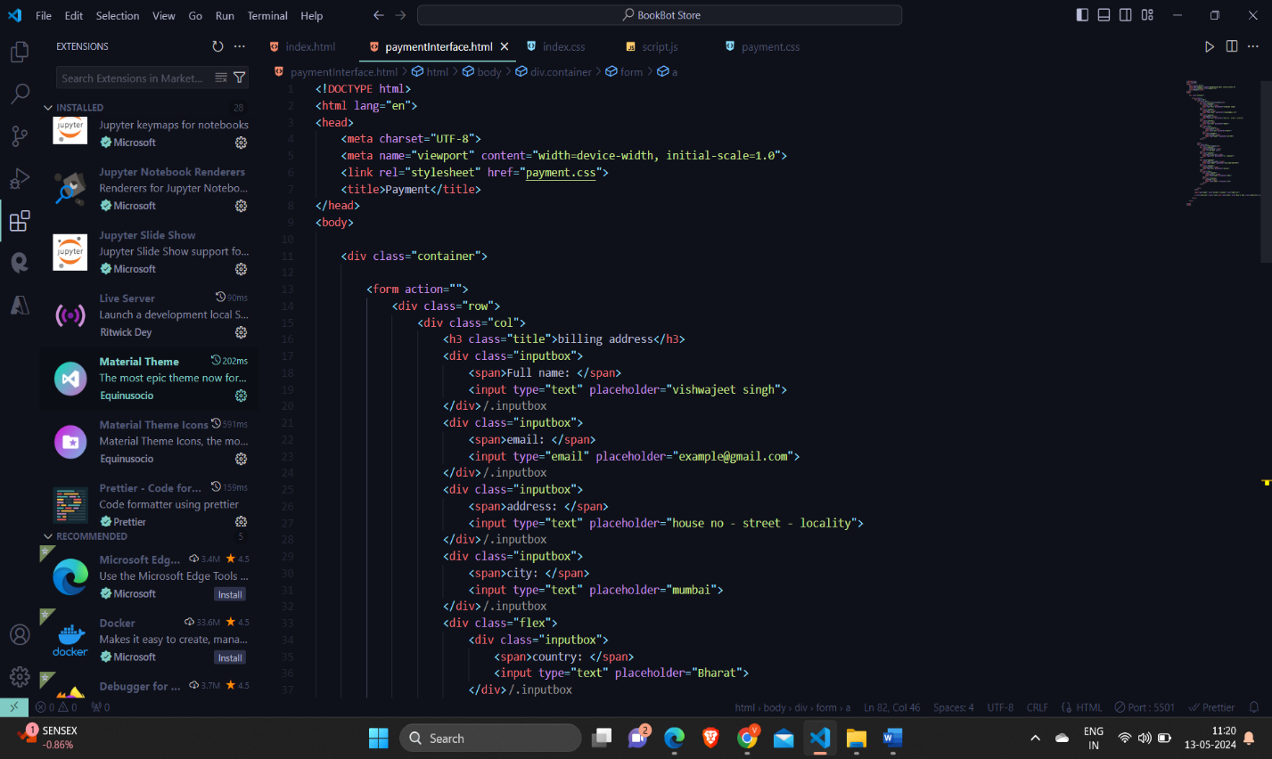

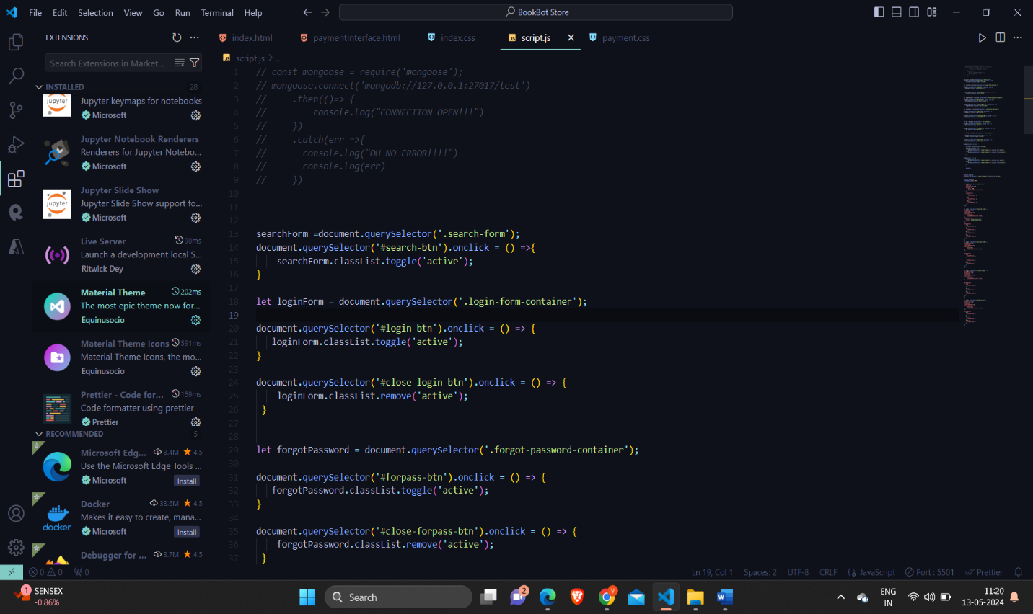

Microsoft Azure: Microsoft Azure is a cloud computing platform and services provided by Microsoft. It offers a wide range of cloud-based services including computing, storage, databases, analytics, networking, machine learning, artificial intelligence, Internet of Things (IoT), and many more. Here are some key aspects of Microsoft Azure:

1. Compute Services: Azure provides various compute services including virtual machines (VMs), containers, serverless computing with Azure Functions, and batch processing with Azure Batch.

2. Storage Services: Azure offers scalable and durable storage options such as Blob storage for object storage, Azure Files for file shares in the cloud, Azure Disk Storage for block storage, and Azure Data Lake Storage for big data analytics.

3. Database Services: Azure provides managed database services including Azure SQL Database for relational databases, Azure Cosmos DB for NoSQL databases, Azure Database for PostgreSQL, MySQL, and MariaDB, and Azure Synapse Analytics for data warehousing.

4. Networking Services: Azure offers networking services to connect cloud resources to on-premises infrastructure, including virtual networks, VPN Gateway, Azure ExpressRoute, Azure Load Balancer, and Azure Traffic Manager for traffic distribution.

5. AI and Machine Learning: Azure provides services for building, training, and deploying machine learning models such as Azure Machine Learning, Azure Databricks, and Azure Cognitive Services for vision, speech, language, and decision-making capabilities.

6. Internet of Things (IoT): Azure IoT services enable customers to connect, monitor, and manage IoT devices at scale. It includes Azure IoT Hub, Azure IoT Central, Azure IoT Edge, and Azure Sphere for secure IoT solutions.

7. Analytics Services: Azure offers a range of analytics services including Azure Synapse Analytics for data integration, exploration, and visualization, Azure HDInsight for Apache Hadoop and Spark clusters, and Azure Stream Analytics for real-time event processing.

8. DevOps and Developer Tools: Azure provides DevOps services such as Azure DevOps for planning, tracking, and deploying applications, Azure DevTest Labs for creating test environments, and Azure App Service for building and hosting web applications.

9. Security and Identity: Azure offers security services including Azure Active Directory for identity and access management, Azure Security Center for threat protection, and Azure Key Vault for managing cryptographic keys and secrets.

10. Hybrid and Multi-cloud Solutions: Azure supports hybrid cloud deployments, allowing customers to seamlessly integrate on-premises infrastructure with Azure services. It also provides solutions for multi-cloud management and migration.

Microsoft Azure is widely used by organizations of all sizes, ranging from startups to enterprises, across various industries, for building, deploying, and managing applications and services in the cloud.

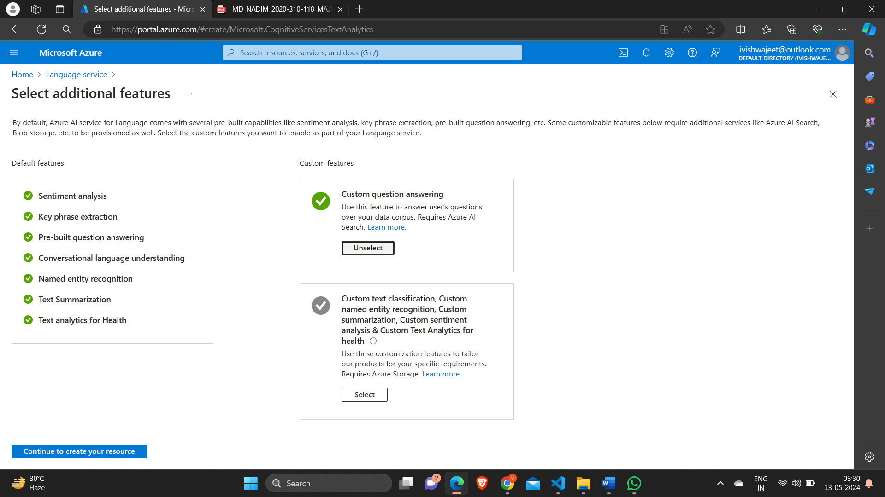

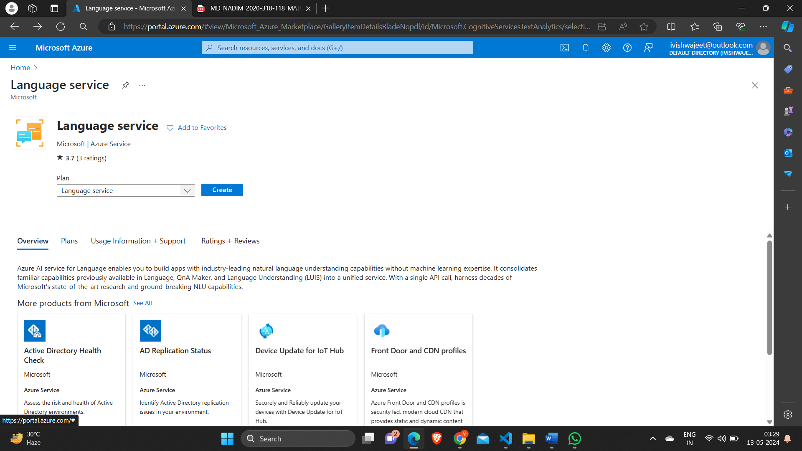

Azure language studio:

Azure AI Language is a managed service for developing natural language processing applications. Identify key terms and phrases, analyze sentiment, summarize text, and build conversational interfaces. Use Language to annotate, train, evaluate, and deploy customizable AI models with minimal machine-learning expertise.

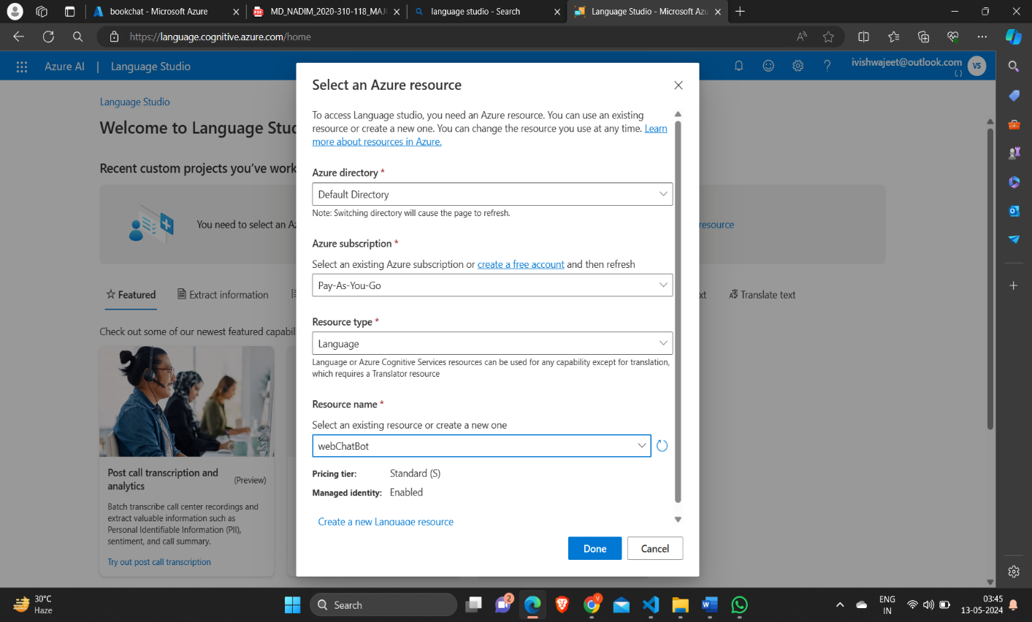

# Azure Cloud Services Used

1. Pay as you go subscription: Azure's Pay-As-You-Go subscription lets you use services without long-term commitments. You're billed based on actual usage, with no upfront costs. It's flexible, scalable, and offers global availability. You can monitor spending and optimize costs using Azure's tools.

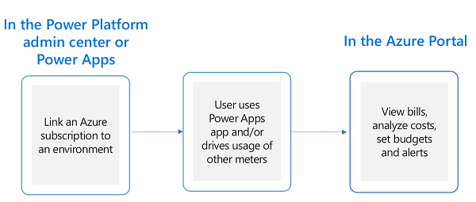

2. Resource group: A resource group in Azure is a logical container that holds related resources. It helps organize and manage resources, applies policies and permissions, facilitates deployment and deletion as a unit, tracks billing and usage, and supports resource locks to prevent accidental changes.

3. Azure AI services: Azure AI services offer pre-built AI models and tools to add intelligent features to applications. They include Cognitive Services for vision, language, and decision-making, Azure Machine Learning for building and deploying ML models, Azure Bot Service for building bots, Azure Databricks for analytics, Azure Cognitive Search for powerful search capabilities, Azure Speech Services for speech-to-text and text-to-speech, and Azure Video Indexer for extracting insights from videos.

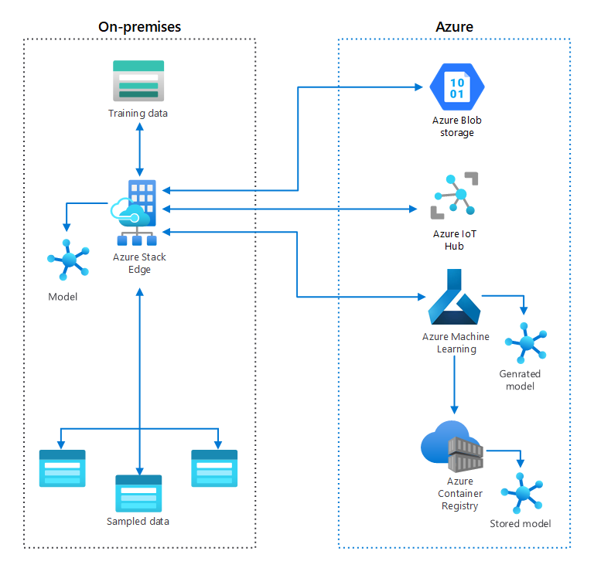

4. Azure App services: Azure App Service is a platform for quickly building, deploying, and scaling web applications and APIs. It supports various languages and frameworks, offers automatic scaling, integrates with CI/CD tools, provides managed infrastructure with built-in security, supports containers, integrates with Azure services, and enables global scalability.

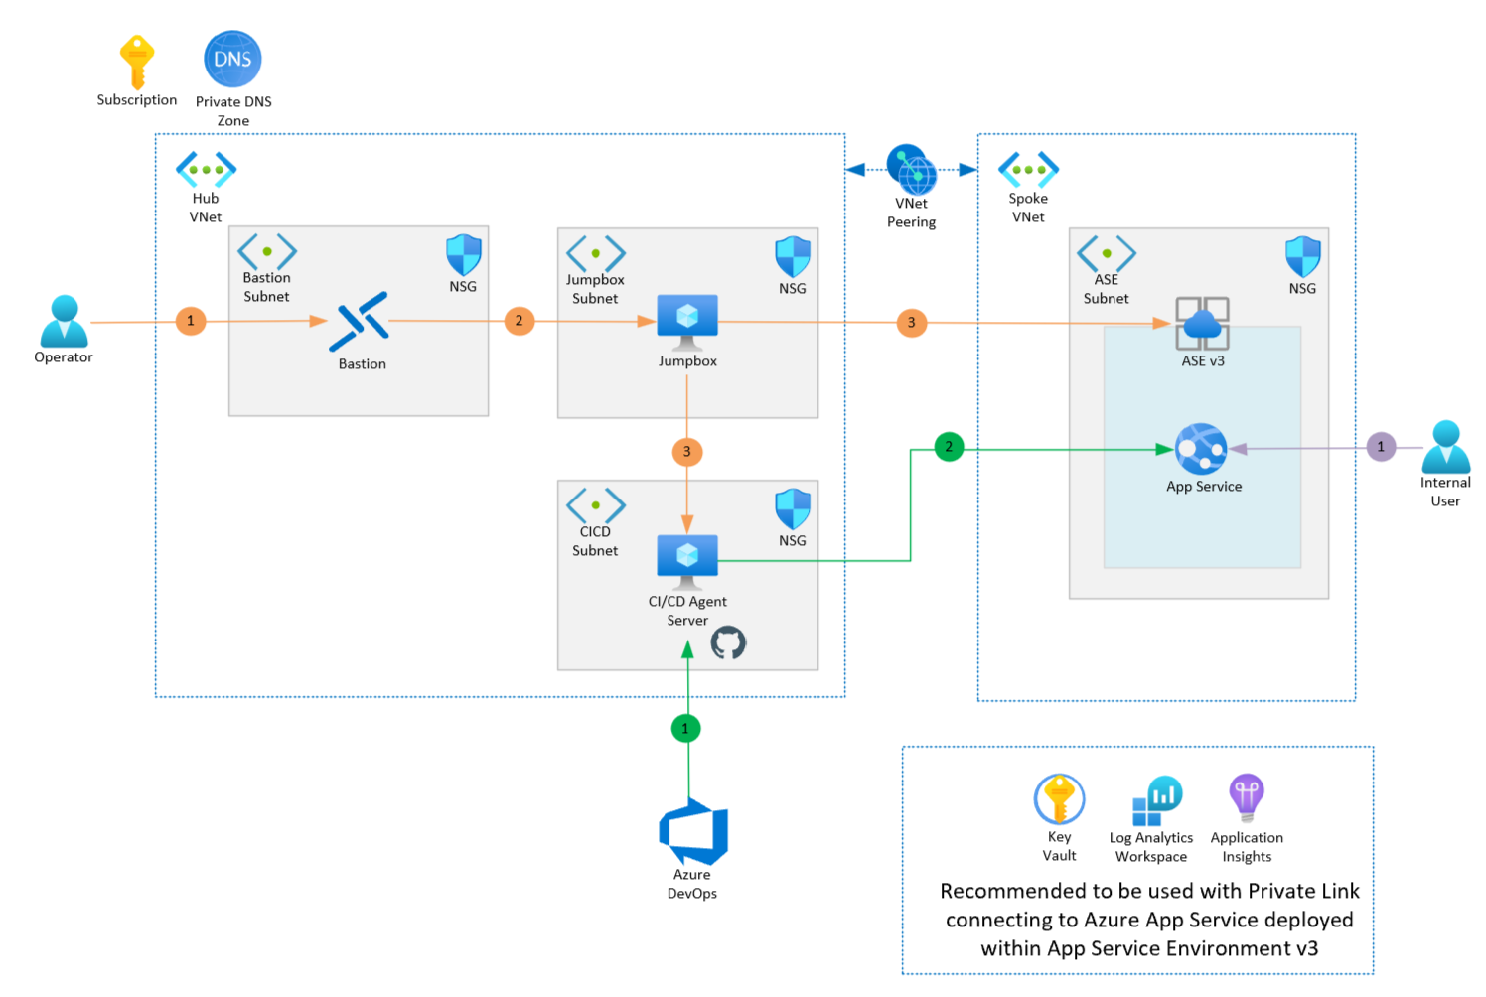

# Snapshots of the project

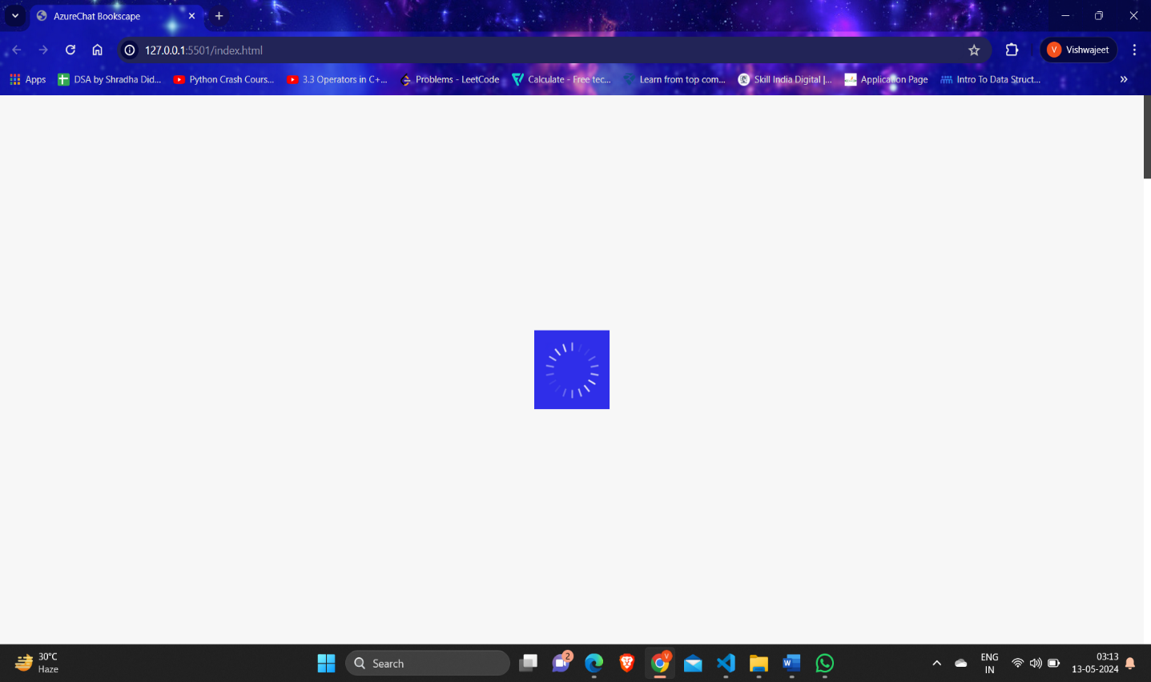

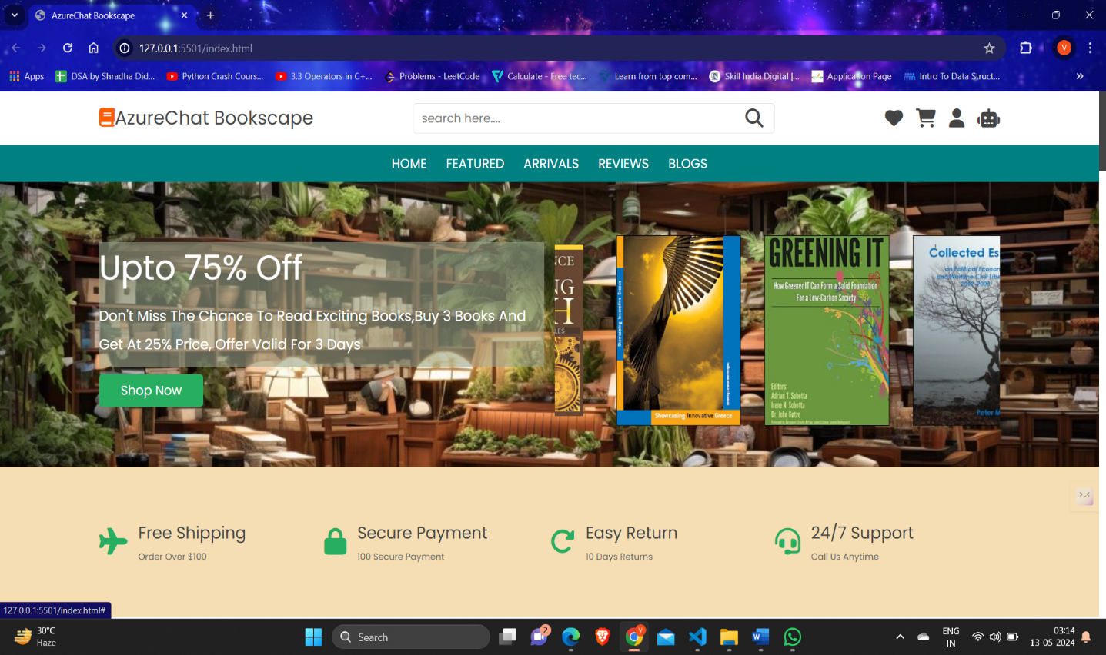

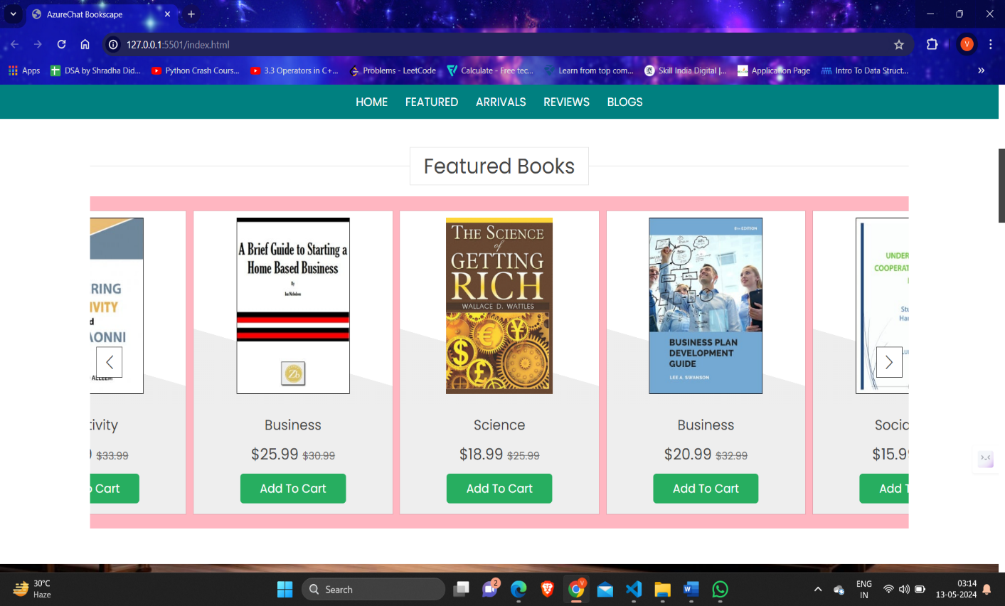

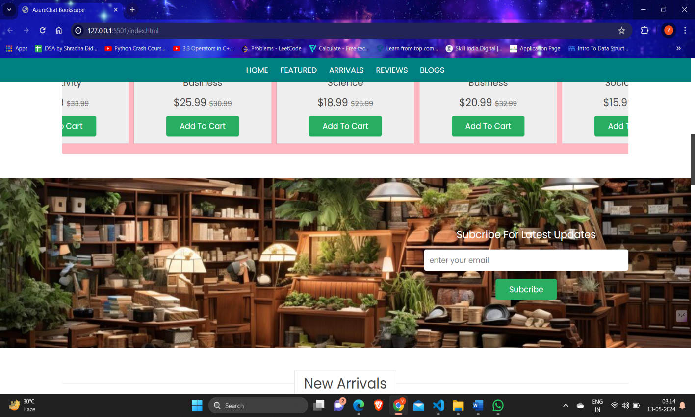

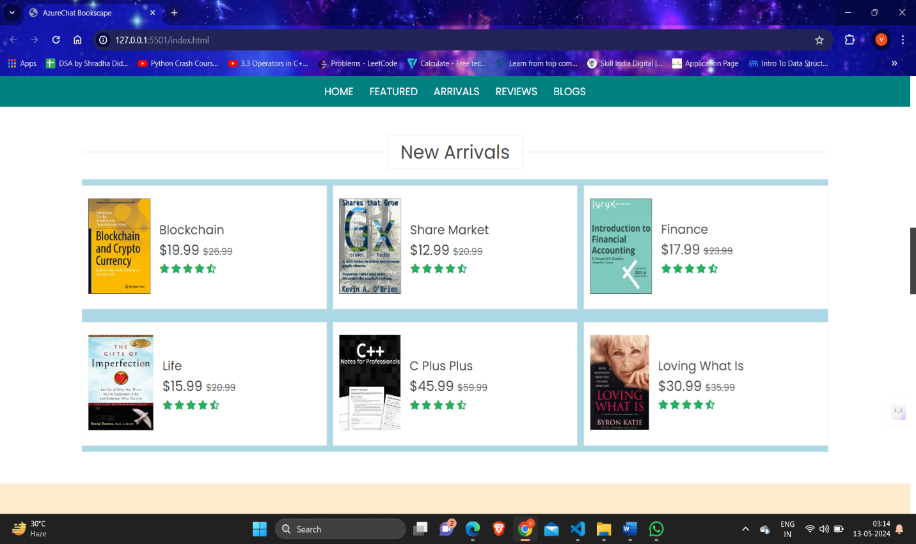



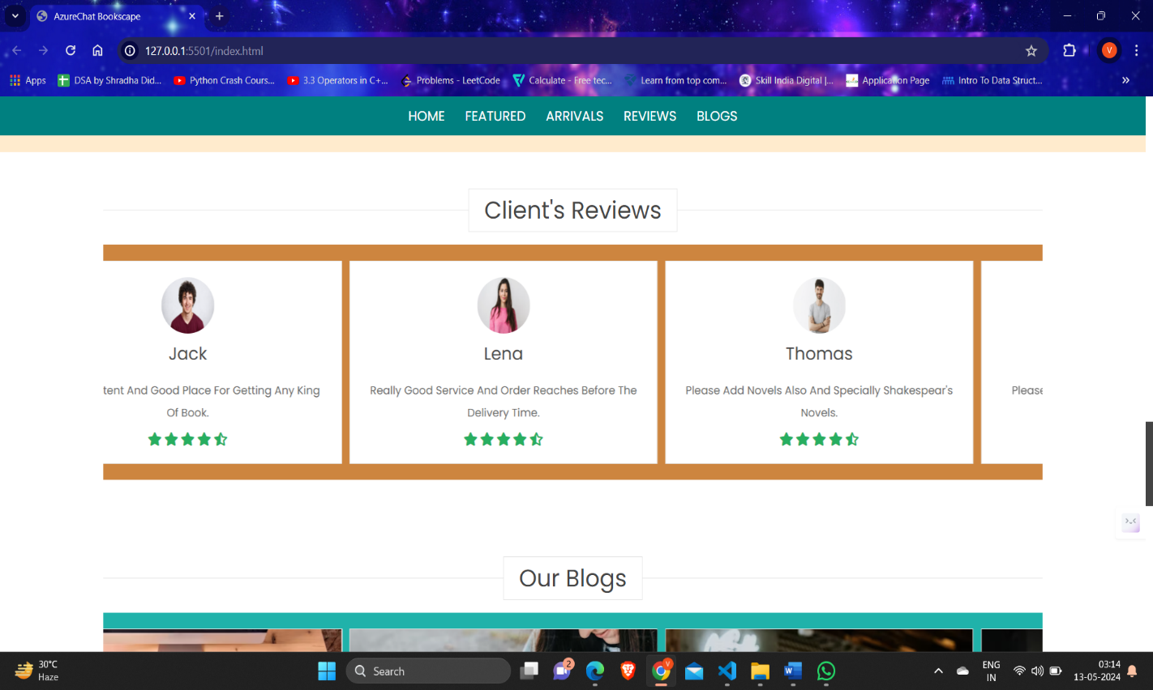

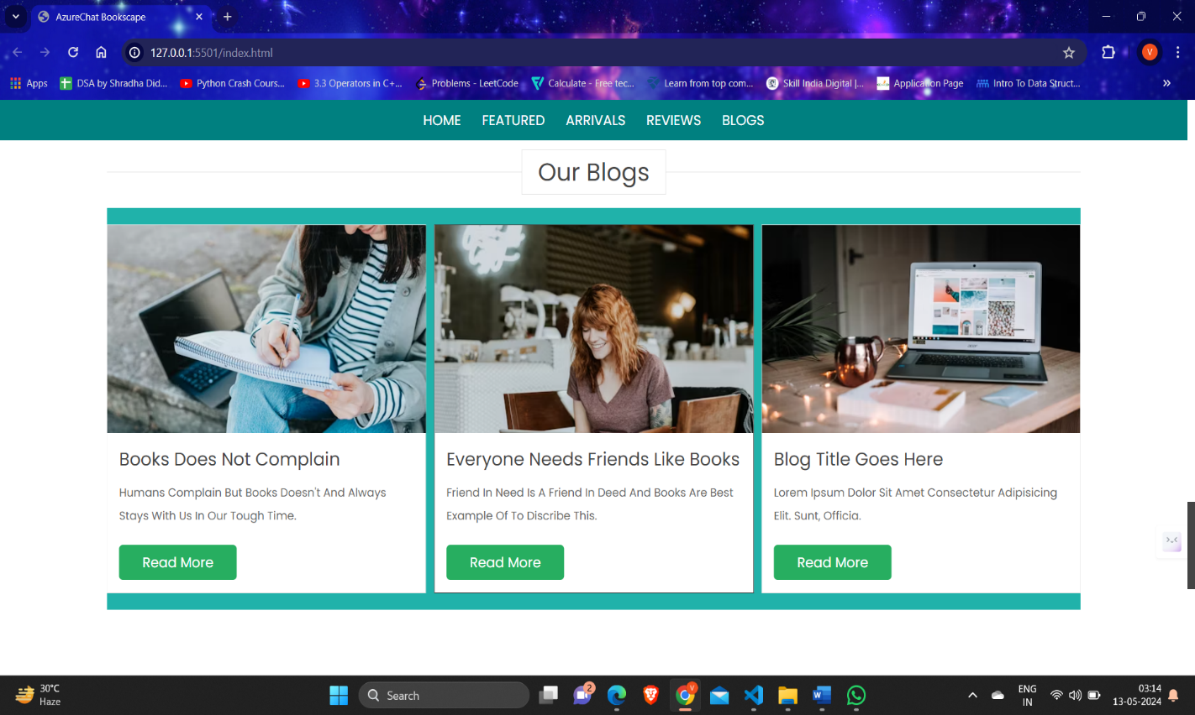

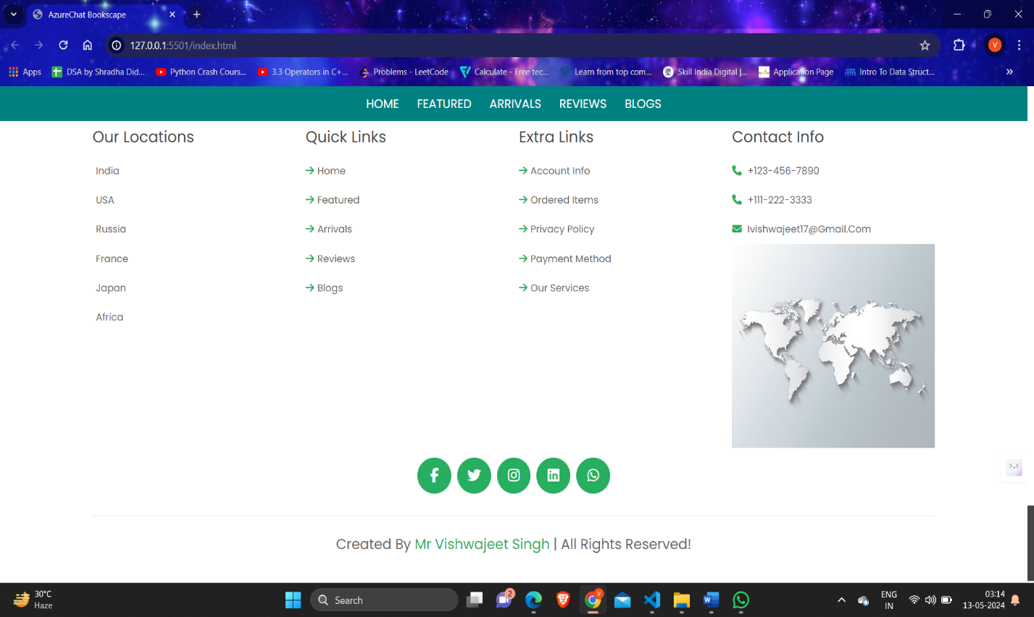

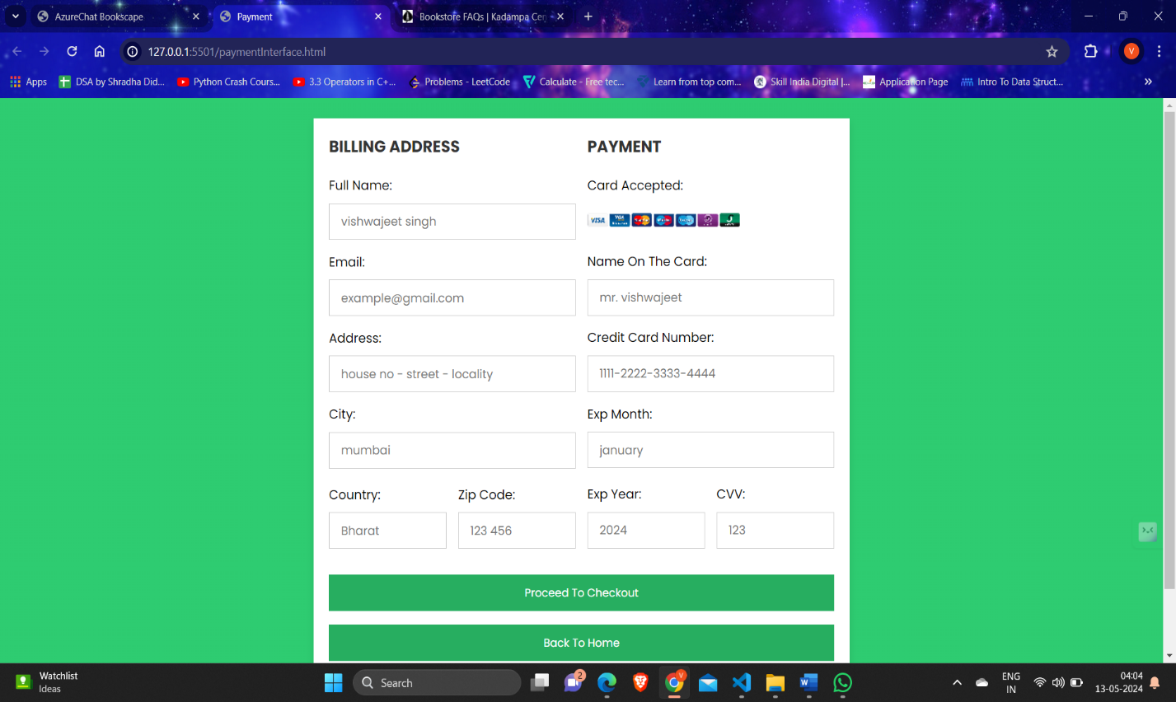

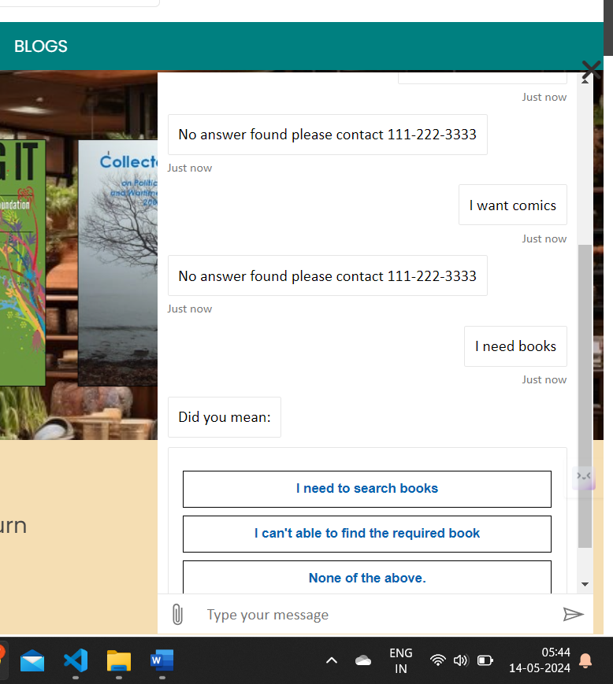

# CONCLUSION

Deploying a secure infrastructure and using AI services for a public-facing application on Microsoft Azure is a multi-faceted endeavor crucial in today's digitally interconnected landscape. Throughout this comprehensive journey, the focus has been on fortifying the Azure environment against an evolving spectrum of threats while ensuring the accessibility, scalability, and reliability essential for public-facing applications.

The culmination of this deployment emphasizes the criticality of a multi-layered security approach. By meticulously implementing robust identity and access management (IAM) policies, fortified network security measures, encryption protocols, and proactive monitoring tools, the infrastructure stands as a bulwark against unauthorized access, data breaches, and potential service disruptions.

Furthermore, the integration of Azure's suite of security services—ranging from Azure DDoS protection and Azure firewall for DDoS protection to Azure Key Vault (AKV) for encryption—has fortified the architecture, fostering a resilient and dependable platform for hosting public-facing applications.

The development and adherence to incident response plans underscore the agility required to swiftly mitigate and recover from potential security breaches, bolstering confidence in the system's ability to maintain operational integrity.

In conclusion, the deployment of a secure Azure infrastructure and Ai services for public-facing applications signifies a commitment to not only safeguarding sensitive data and user trust but also fostering an environment conducive to seamless, high-performance, and uninterrupted experiences. The continuous pursuit of best practices, compliance adherence, and vigilance in embracing emerging security trends shall perpetuate the resilience and adaptability of this secure infrastructure in the ever-evolving digital landscape.

# Limitations

The limitations of an Azure-based public placing platform could vary based on the specific implementation and configuration, but here are some potential limitations one might encounter:

1. Scalability Limits: While Azure offers excellent scalability options, there may be limitations depending on the specific services used, pricing plans, and configurations. Scaling beyond certain thresholds may incur additional costs or require architectural changes.

2. Latency: Depending on the geographical location of Azure data centers and the distribution of users, there might be latency issues, especially for users accessing the bookstore from regions far from Azure data centers.

3. Dependency on Azure Services: Relying heavily on Azure services could pose a risk if there are any service outages or disruptions. While Azure is generally reliable, occasional downtime can still occur.

4. Data Sovereignty and Compliance: Azure operates data centers globally, which could raise concerns regarding data sovereignty and compliance with regulations such as GDPR, particularly if the platform serves customers in regions with strict data protection laws.

5. Vendor Lock-In: Building the platform using Azure services might lead to vendor lock-in, making it challenging to migrate to other cloud providers in the future if needed.

6. Cost: While Azure provides a pay-as-you-go pricing model, costs can still accumulate, especially if resources are not optimized or usage spikes unexpectedly. It's important to monitor usage and optimize resource allocation to avoid unexpected expenses.

7. Technical Complexity: Azure offers a wide range of services and features, which can be overwhelming for inexperienced users. Setting up and managing an Azure-based online bookstore may require significant technical expertise.

# Future Scope

The future scope for the deployment of Azure secure infrastructure and AI services is vast, with opportunities for innovation and advancement across various industries. Here are some potential areas where this combination could be leveraged:

1. Cybersecurity: Enhancing Azure's secure infrastructure with AI-powered threat detection and response capabilities can strengthen defense mechanisms against cyber threats. AI algorithms can analyze vast amounts of data to detect anomalies, identify potential security breaches, and automatically respond in real-time to mitigate risks.

2. Compliance and Governance: Implementing AI-driven compliance and governance solutions on Azure can help organizations ensure regulatory compliance, streamline audit processes, and enforce security policies effectively. AI can assist in automating compliance assessments, identifying compliance gaps, and providing actionable insights for risk management.

3. Data Privacy and Protection: Utilizing Azure's secure infrastructure and AI services for data privacy and protection can enable organizations to safeguard sensitive data, detect unauthorized access or usage, and ensure compliance with data protection regulations such as GDPR. AI-driven encryption, anonymization, and access control mechanisms can enhance data privacy and minimize the risk of data breaches.

4. Predictive Maintenance: Deploying AI-powered predictive maintenance solutions on Azure infrastructure can help organizations optimize asset performance, reduce downtime, and extend equipment lifespan. By analyzing telemetry data from IoT devices, AI algorithms can predict equipment failures proactively, schedule maintenance activities efficiently, and optimize resource allocation.

5. Customer Experience Enhancement: Leveraging AI services on Azure, such as natural language processing (NLP) and computer vision, can enhance customer experiences across various touchpoints. AI-driven chatbots and virtual assistants can provide personalized assistance, answer customer inquiries, and facilitate self-service interactions, while computer vision technologies can enable visual search, product recommendation, and augmented reality experiences.

6. Healthcare Diagnostics and Treatment: Deploying AI-powered healthcare solutions on Azure infrastructure can revolutionize diagnostics, treatment planning, and patient care. AI algorithms trained on medical imaging data can assist radiologists in detecting abnormalities, diagnosing diseases, and predicting treatment outcomes with higher accuracy. Additionally, AI-driven predictive analytics can help healthcare providers identify patients at risk of developing certain conditions and intervene early to prevent adverse health outcomes.

7. Financial Fraud Detection: Enhancing Azure's secure infrastructure with AI-powered fraud detection capabilities can help financial institutions combat fraudulent activities, such as payment fraud, identity theft, and money laundering. AI algorithms can analyze transaction data in real-time, detect suspicious patterns or anomalies, and flag potentially fraudulent activities for further investigation.

8. Supply Chain Optimization: Utilizing AI services on Azure for supply chain optimization can improve operational efficiency, reduce costs, and enhance decision-making processes. AI algorithms can analyze supply chain data, predict demand fluctuations, optimize inventory levels, and identify opportunities for process improvement and cost savings.

9. Smart Cities and Infrastructure Management: Deploying AI-powered solutions on Azure infrastructure can enable smart cities and infrastructure management initiatives, such as traffic optimization, energy efficiency, and public safety. AI algorithms can analyze sensor data from IoT devices, optimize traffic flow, detect anomalies in infrastructure systems, and facilitate proactive maintenance and incident response.

10. Environmental Monitoring and Sustainability: Leveraging AI services on Azure for environmental monitoring and sustainability initiatives can help organizations monitor environmental conditions, assess ecological impact, and implement conservation measures. AI algorithms can analyze environmental data, predict environmental trends, and support decision-making processes for sustainable resource management and conservation efforts.

By combining Azure's secure infrastructure with AI services, organizations can unlock new capabilities, drive innovation, and address complex challenges across various domains, ultimately leading to improved efficiency, enhanced security, and better outcomes for businesses and society as a whole.

## BIBLIOGRAPHY

* Software –

1. V S code
2. HTML, CSS & JavaScript
3. Azure AI Services
4. Azure Language Services

* Sites –
* YouTube
* Microsoft Azure
* Google

# PLAGIARISM REPORT

# 

# 

# 